Welcome

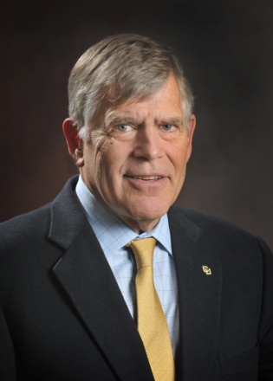
Welcome to a university for the 21st century.
The University of Colorado Denver plays a critical role in the development and well-being of the state and its citizens, with a dedication to advancing and inspiring learning and teaching; community and culture; discovery and innovation; and health and wellness; we are the region’s premier urban university.
By combining the excellence of our academic programs at CU Denver with the extensive research and teaching of the CU Anschutz Medical Campus in Aurora, we provide a unique option in the University of Colorado system. Here you will benefit from:
Academic choices—more than 130 degree programs in 13 schools and colleges
A spirit of collaboration—the synergy of combining disciplines to create courses of study like public health administration, bioengineering or health and behavioral sciences
Outstanding location—access to a vibrant, safe urban lifestyle, alongside opportunities to gain experience in projects and internships at businesses and corporations throughout the Denver metropolitan area
We are a leading economic driver and job creator for the state of Colorado—a valued partner in our community and a place of academic excellence for you, the students who have turned to us to pursue your educational dreams.
Here you'll have access to the opportunities you need to achieve your educational goals. You will meet faculty dedicated to excellence in the classroom and in research laboratories and fellow students who are diverse, goal-oriented and energetic. Whether you engage in undergraduate or graduate studies, the University of Colorado Denver degree has global respect and you can rest assured that you will have been well-prepared for the next stage of your work or academic life.
It’s a privilege to have you join us.

Donald M. Elliman, Jr.
Chancellor
University of Colorado Denver

CU Denver Executive Team

Donald M. Elliman, Jr.
Chancellor
BA, Middlebury College
Lilly Marks
Vice President for Health Affairs and
Executive Vice Chancellor for Anschutz Medical Campus
BS, University of Colorado Boulder
Leanna Clark
Vice Chancellor of Marketing and Community Engagement
BS, University of Colorado Boulder
Richard Krugman
Vice Chancellor for Health Affairs and Dean of School of Medicine
AB, Princeton University
MD, New York University
Roderick Nairn
Vice Chancellor for Academic and Student Affairs and Provost
BSc, University of Strathclyde (Scotland)
PhD, University of London (England)
Jeff Parker
Vice Chancellor for Administration and Finance
BS, Western State College
Richard Traystman
Vice Chancellor for Research
MS, Long Island University
PhD, The Johns Hopkins University

